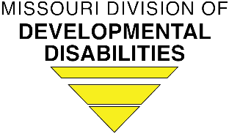Department of Mental Health

Division of Developmental Disabilities

Request to Challenge

DMH DD Level 1 Medication Aide Examination

Name:

Address:

Email Address:       Telephone:

Date of Birth:       Social Security Number:

I request consideration to challenge the written and practicum test without completion of the course because (check appropriate response)

I have successfully completed a pharmacology course

Institution:

Date of completion:

Please attach a copy of transcript.

I have successfully completed a medication administration course of at least 16 hours

Instructor:

Date of completion:

Agency sponsoring course:

Please attach a copy of your certificate.

Please attach evidence of the curriculum content.

Other

Please Explain

Signature:

Submit this request to [Medaide@dmh.mo.gov](mailto:Medaide@dmh.mo.gov)

(For Office Use Only) Your Request to Challenge has been:

Approved. Please present this approval to an approved instructor for testing.

Denied.

Reasons/Comments:

If you have questions or concerns please contact:

Email Medaide@dmh.mo.gov